1. Let’s test the hypothesis than men smoke more than women at the α = 0.10 level.
Hypotheses
H0: men don’t smoke more than women
Ha: men smoke more than women

Assumptions

- Let p1 be the unknown proportion of men who smoke and X1 the random variable which equals 1 if a man is a smoker and 0 otherwise: X1~>B(p1)
- Let p2 be the unknown proportion of women who smoke and X2 the random variable which equals 1 if a woman is a smoker and 0 otherwise: X2~>B(p2)

In the database, we observe:
- the value of X1 for each of the n1 individuals (men) of a sample with
n1 = 76,

- the value of X2 for each of the n2 individuals (women) of a sample with
n2 = 88.

The individuals being all different, the samples are independent.
We make the assumption that p1>p2. To test this we conduct the
2-Prop-Z-Test. It is unilateral on the right.

Code
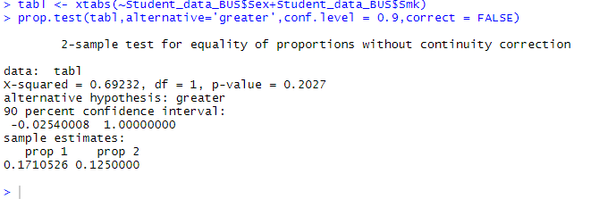
Figure 1: R output for the 2-Prop-Z-Test

Conclusion & Intterpretation
With an α of 0.10 and a p-value=0.2027>0.1, we fail to reject the null hypothesis and state we don’t have enough evidences to prove that men smoke more than women.

2. Let’s provide and interpret a 95% confidence interval for the difference in hours worked per week for those who consume caffeine and those who don’t.
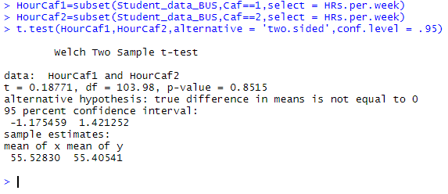
Figure 2:R output for the 95% confidence interval for the difference in hours worked per week for those who consume caffeine and those who don’t

We are 95% confident that confidence interval for the difference in hours worked per week for those who consume caffeine and those who don’t is between -1.1754 and 1.421. Therefore, we state the two groups are not statically different

- Let’s provide and interpret a 97% confidence interval for the difference in average reaction time between men and women.

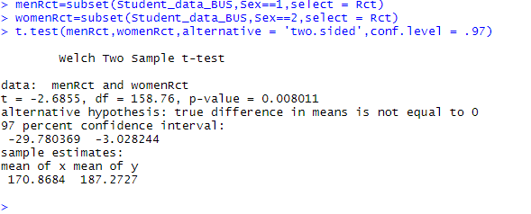
Figure 3:R output for the 97% confidence interval for the difference in average reaction time between men and women

We are 97% confident that the confidence interval for the difference in average reaction time between men and women is between -29.7803 and -3.0282.

- Let’s test the hypothesis that smokers have a lower average pulse rate than non smokers.

Hypotheses
H0: smokers don’t have a lower average pulse rate than non smokers
Ha: smokers have a lower average pulse rate than non smokers

Assumptions
Let X1 and X2 be the random variables associated respectively with the pulse rate of smokers and those of non smokers.

Let m1 be the smokers average pulse rate and m2 the non smokers one
We make assumption that m1<m2 . To test this we conduct the t-test which involved the normality of samples so let’s check the normality of X1 and X2.

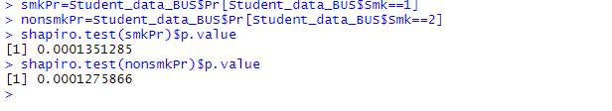
Figure 4:R output for the Shapiro Wilk test

X1 and X2 don’t follow normal distribution. But according to the course , we state that we can use t-test to test these hypotheses.

Code
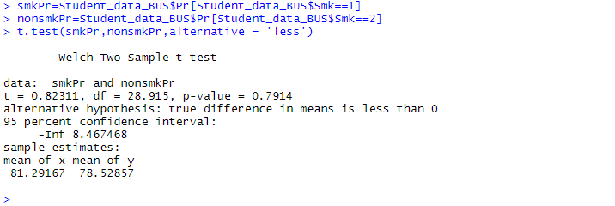
Figure 5: R output for the T test

Conclusion & Interpretation
With a p-value =0.7914 and an α of 0.05 , we fail to reject the null hypothesis and state we don’t have enough evidences to prove that smokers have a lower average pulse rate than non smokers.

- Let us provide and interpret a 90% confidence interval for the difference in proportion of men who consume caffeine vs. women who consume caffeine.

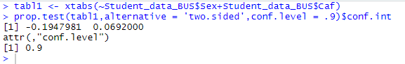
Figure 6: R output for the 90% confidence interval for the difference in proportion of men who consume caffeine vs. women who consume caffeine

We are 97% confident that the confidence interval for the difference in proportion of men who consume caffeine vs. women who consume caffeine is between
-0.1947 and 0.0692.

- Test the hypothesis that women have a lower starting salary than men.

Hypotheses:
H0: Women don’t have a lower starting salary than men
H1: Women have a lower starting salary than men

Assumptions
We choose independent Means test to answer this question .
Let X1 and X2 be the random variables associated respectively with the starting salary of men and those of women.
Let m1 be the starting salary average of men and m2 women one
We make assumption that m1>m2 . To test this we conduct a t-test which involved the normality of samples so let’s check the normality of X1 and X2.

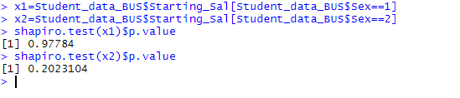
Figure 7: R output for the shapiro-test

Since that figure, we state that X1 and X2 follow a normal distribution. Therefore, t-test for the comparison is reliable.
Let’s do the t-test one .
Code :
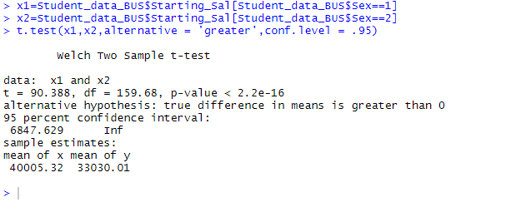
Figure 8: R output for the t-test

Conclusion & Interpretation
With an α of 0.05 and a p-value <2.2e-16, we reject the null and state that we have sufficient evidence to support that women have a lower starting salary than men.

